Picture a thriving culture of STEM and FIRST through West Virginia. This picture is a puzzle that uses the four concepts of the MARS Plan as its pieces. The MARS plan, formerly known as the West Virginia Plan, is a four tiered strategy based on Barriers, Partnerships, Community and Sustainability. This plan helps us achieve our mission to create and instill a model of sustainability that enables students to inspire themselves and pass inspiration forward. The plan originally responded to the rural, lightly populated, and geographically distributed features of WV. Every challenge is an opportunity, and the unique features of our state led us to unique solutions. Our innovations in building and sustaining teams are spreading to other rural areas, and our mission provides a model for sustaining inspiration around the world. Who are we? We are budding entrepreneurs, engineers, physicists, writers, artists, and computer programmers. We are working with leaders in innovative technology and business. We are the students that will have a hand in creating technologies to solve the world’s biggest problems. We are MARS and we are ready for a new generation. Are you?
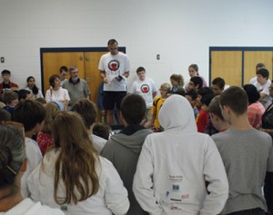
The first piece of the puzzle is our team’s innovative solution to the barriers preventing sustainable FIRST robotics and STEM programs in WV. These barriers include geography, education, economy, and technical infrastructure. Many people aspire to start teams in their community. However, here in the mountain state, students are separated by great distance and often face hazardous weather or terrain. These barriers make it difficult to start successful teams. In many places there are other FRC teams nearby, but in our state the closest FRC team is 4 hours away. This makes it difficult to consult with other teams. The solution presented in the MARS plan is to actively develop mentoring programs at each level of FIRST, starting by creating FLL programs in the area. By doing this, we hope that they will become a feeder system for higher levels of FIRST. We provide mentoring at the FLL level through bi-weekly sessions at a central location for all the teams in our area and we have built a practice facility for regional FTC and FRC teams. Currently MARS supports or mentors all levels of FIRST, 2 Jr. FLL, 69 FLL, 2 FTC, and 2 FRC teams throughout not only our state, but also Pennsylvania and Maryland. Our annual MARS FLL scrimmage has grown from 10 teams at its start in 2008 to our maximum capacity of 24 teams in 2013. This event will become a state tournament qualifier in 2014. We also supported the development of two other WV FLL scrimmages in 2013 that will become state qualifiers in 2014. This past FLL season, we developed a tablet-based, real time scoring system for FLL competitions that we are hoping will soon be adopted by FIRST. The Appalachian Robotics Alliance page on our web site lists locations and contacts for FIRST teams in the state and serves as a nexus for all levels of FIRST teams to meet, interact, and share information. We hold a FRC Kick Off party annually where WV teams can brainstorm with each other about the coming season. We’ve also helped teams connect with sponsors and write grants. In short, the challenges of the Mountain State have inspired us to find solutions to the first piece of the puzzle.
The second piece of the puzzle is our team’s development of partnerships that let us share the MARS plan with other teams across the state. Because WV is a rural state with fewer resources than most others, it is vital to a team’s survival to partner with organizations that can aid them in their success. They must have organizations in their area to provide mentors, funding, and guidance. We partner with groups such as 4-H and NASA to help spread the Plan to remote teams otherwise beyond our reach. One of our main partners is 4-H. 4-H provides a diverse mentor base, team-oriented structure, and has a strong foundation in every WV county. Partnering with 4-H helps us grow our own team while helping to develop FLL teams in rural areas, and also helps them meet their goal of providing STEM educational opportunities for youth. As part of our partnership, MARS provides robotics programs during 4-H summer camps in WV. Linked with funding from NASA, the 4-H program creates the perfect atmosphere to house a team and keep them active in their community.
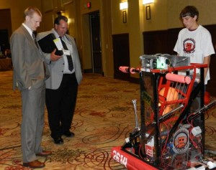
We partner with many programs such as NASA, WVU, and the other FRC teams in our state that provide us with invaluable resources. NASA provides funding, 3D printing, and internship opportunities for our team members. Last summer, 9 of the 20 internships at the local NASA facility were filled by MARS students. We were also contracted by NASA to build LEGO models of their Magnetospheric Multiscale and Global Precipitation Measurement Satellites (MMS and GPM). Not only do we sell hundreds of models as a fundraiser for the team, we also developed a curriculum that goes along with the models to be used in classrooms worldwide. Our partnership with WVU has proved to be a phenomenal opportunity for both organizations. They provide significant funding for our team which enables us to complete the many outreach events we do every year. Our close partnership with WVU also gives us access to a work space that includes access to three shops. This year, in conjunction with WVU, we will also be hosting the first ever 26 hour and 14 minute FRC off season endurance event. WVU is covering the costs and allowing us to use their Recreational Center for the event. The event will not only be a fun chance to compete with teams from all over the country, but it will also give students an opportunity to explore options for college and introduce some of the most talented students in the country to WVU. The last major partnership is with our fellow FRC teams within the state. In partnership with NASA and the other FRC teams, we help run the FLL State Tournament. We also work closely with NASA to secure funding for the other WV FRC teams. The second piece of the puzzle is in place: our partnerships that let us further the appreciation for STEM in our state, in surrounding states, and throughout the world.

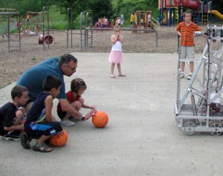
The third piece of the puzzle is our love for the community. In the seven years our team has existed, we have become a presence in our community by creating a thriving FLL and FTC program as well as attending many outreach events. We teach at science camps as well as making appearances at tech conferences, parades, and children’s museums. This year we attended the October Sky Festival and the State Fair both of which are located in economically depressed areas of our state. Our robots have taken part in ribbon cutting ceremonies and have been the focus of 41 newspaper articles, 9 regional news stories, and a 15 minute feature in a statewide PBS documentary. We also attend local farmers’ markets to promote STEM and sell FIRST LED Light Bulbs.
The fourth and final piece completes the puzzle: sustainability. Members of our FLL programs move on to our FTC and FRC programs, creating a feeder system for FIRST in the community. In the past year, we have started 2 FTC teams, one of which qualified for the State Tournament their rookie year and is now hosting their own scrimmage at our practice building. Through the model of the MARS plan, we teach teams how to be sustainable and to not rely too heavily on any one sponsor or program. Our plan does more than just aid the team’s sustainability, it also inspires them to become more than just a robotics team. They are a continuation of a movement that started in the heart of The Mountain State, a movement that is now taking thousands by storm.
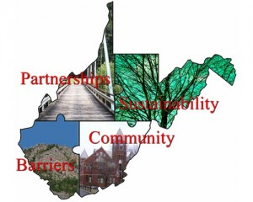
Our team has grown from 12 students and a handful of mentors in 2008 to 42 students and a diverse group of mentors. We have grown not only in number, but we have also grown as a family and have become a presence in our community. We have vastly expanded youth access to FIRST and STEM in our state. In the past seven years we have had 14 students awarded internships from NASA. Every student that has been part of our team has graduated from high school and gone on to pursue some form of post-secondary education. We have also done many things that give us a world presence. We created curriculum for the MMS and GPM models designed for NASA which is used internationally, made software from our team available online, mentored teams from across the USA in business plan and presentation development, and participated in online mentoring sessions for Australian teams.
Now we are working on spreading our MARS plan and the sustainability it provides at an international level. Our MARS plan in the past has been focused locally. We worked mostly within our state due to the barriers that exist within, but we are not alone in our situation. There are many other rural states and other countries that are struggling with the same complications we are. We have been spreading the MARS plan to southwestern Pennsylvania and western Maryland and have begun developing it for international use. It is our hope that this will help to inspire students to live a life that will make a difference and be remembered for years after they are gone. In the words of Chuck Palahniuk “We all die. The goal is not to live forever. The goal is to create something that will.” It isn’t hard to see that FIRST and MARS aren’t just about the robots. It’s about building a generation with both the knowledge and the values to create a successful world. One of our coaches often says “If we’re building robots and breaking people then we aren’t doing our job.” At the end of the day, we realize that we may grow in number, and the words that inspired us may grow to inspire millions. At the heart of all of that, our mission is still the same: to enable people to find inspiration within themselves and pass that inspiration forward.
